E-Notebook ISIS/Draw Integration Requirements

Copyright © 2003-2005 CambridgeSoft Corp. All Rights Reserved.
This document is the property of CambridgeSoft Corp. Reproduction or transmission of this document, in whole or in part, is not permitted except under the provisions of a confidentiality agreement, signed by an authorized representative of CambridgeSoft Corp.

Revision History
Version | Date | Author | Notes
0.1 | Dec 22, 2004 | Fred Putnam | Initial draft
0.2 | Dec. 22, 2004 | Fred Putnam | Changed “field” to “column” in section 3.1.1
0.3 | Jan. 4, 2005 | Fred Putnam | Revised per recent design discussions
0.4 | Jan. 5, 2005 | Fred Putnam | Revised per recent design discussions
0.5 | Jan. 5, 2005 | Fred Putnam | Requirement added: that format conversions be acceptable
0.6 | Jan. 10, 2005 | Fred Putnam | Storage and rendering sections revised.

Background

E-Notebook was originally designed with the ChemDraw Plugin Pro as its molecular structure and reaction drawing tool. However, many CambridgeSoft customers currently use MDL ISIS/Draw as their corporate standard for both structure and reaction drawing, and for storing and retrieving structures and reactions from their corporate chemical registration, reagent, inventory, and other databases. These customers require CambridgeSoft E-Notebook to support their use if ISIS/Draw for these purposes.

Notes: (1) Throughout this document, “structures” will be used as referring to both structures and reactions. (2) This document refers only to requirements around rendition and editing.

General Requirements

Customers that prefer to use ISIS/Draw generally want to have a seamless replacement of ChemDraw, where every use of ChemDraw in E-Notebook is replaced by ISIS/Draw. They don’t want to use ChemDraw anywhere in E-Notebook. In every case where ChemDraw is used, they would like to have that use replaced by ISIS/Draw in a way that, to the extent possible, does not degrade ease of learning and use.

Look and feel

Ideally, software applications should have a common look and feel throughout. When integrating existing applications, however, this is limited due to their different look and feel. The design should minimize differences in look and feel to the extent possible, while still retaining the look and feel of E-Notebook, ChemDraw, and ISIS/Draw when they are in use.

For the most part the way that the two products render structures is identical – this is the most important element of common look and feel.

Functionality

The basic E-Notebook related functionalities that ChemDraw and ISIS/Draw have in common, are as follows:

- Drawing structures
- Rendering structures from databases
- Providing structures that are used in searching structure databases

Beyond these basic common functionalities, there are many small differences in the two products, such as the way stereochemistry is represented, whether terminal hydrogen atoms appear, etc. In general, the design should allow the user to leverage the different functionalities of ChemDraw and ISIS/Draw, while providing a clean and understandable model to the user of what the common functionalities are.

File and storage formats
Each drawing package has its native storage format. For ChemDraw this is usually cdxml or ‘cdx’, and for ISIS/Draw it is usually sketch or ‘skc’. Both packages should be able to read and write the ‘mol’ format, but the two packages differ somewhat in their support of the mol format. E-Notebook is required to have the capability to convert to and from these different formats. This capability is provided by ChemDraw, and most cases this is straightforward.

E-Notebook stores structures in the cdxml format, and the cdxml stored structures are used for searching. Optionally, to attain maximum functionality, E-Notebook can also store structures in other formats such as skc. Some format conversions between skc and cdx are unavoidable, because of ChemDraw based procedural logic in E-Notebook. Therefore, it is a requirement that format conversions be acceptable.

Interoperability

E-Notebook should support interoperability with respect to switching between use of ChemDraw and ISIS/Draw, because customers require to be able to switch from ISIS/Draw to ChemDraw or the reverse. In cases where it is required, sketch file storage should be able to be added without any modification to the database structure by adding it to the xml that is used for cdx.

Switching method
Administrators may specify the drawing package setting as follows:

- ChemDraw only
- ISIS/Draw only
- ChemDraw or ISIS/Draw, depending on a per-user preference setting

In the case where users may set their preference, the preference should be able to be changed ‘on the fly’, without logging out and logging back in to E-Notebook.

Look and feel specifics

Structure rendering in E-Notebook sections
ChemDraw should be used for rendering. Rendering should be in place – i.e. shown directly in the field.

The following examples show the same reaction as rendered by ChemDraw and ISIS/Draw. Note that the rendering is substantially the same apart from font differences, the straightness of lines, etc. For this reason, there is no strong reason to do the rendering with ISIS/Draw. Rendering with ChemDraw provides the following advantages: (1) it provides a visual check on the format conversion to cdx for the user, and (2) the rendering is done in the format used for storage. ChemDraw is being enhanced in order to lessen the rendering differences with ISIS/Draw.

ChemDraw rendering
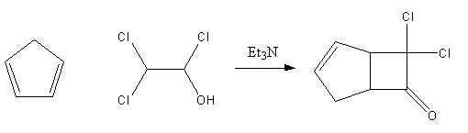
reaction drawn and rendered by the CambridgeSoft ChemDraw control

ISIS/Draw rendering
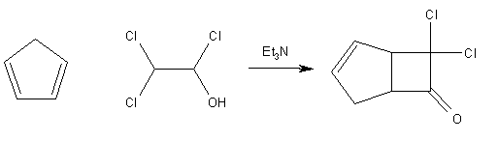
reaction converted to skc format and rendered by the MDL Form Box control

Structure editing

Editing may be either in place or in a separate window.

ChemDraw editing

As the ChemDraw control has in-place editing functionality, structures are edited in place, as shown below.

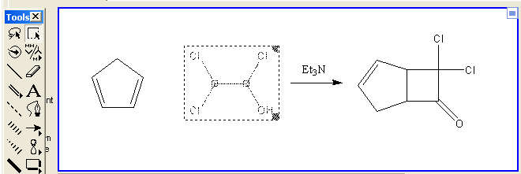

ISIS/Draw editing

ISIS/Draw provides only editing by the ISIS/Draw application, so the user should double-click on the Chemical Structure field, and ISIS/Draw should open for editing,

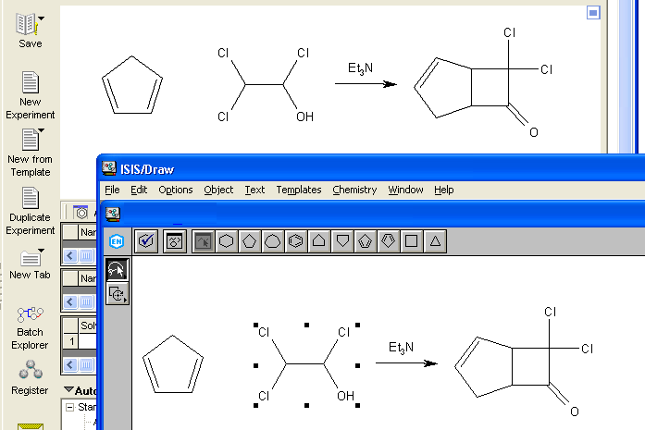

When done editing, the user should click on the close icon, , to return to E-Notebook.

Copy and paste structures
The Chemical Structure field should support copy and paste of either ChemDraw or ISIS/Draw structures to and from other applications like Excel and Word. Copy and Paste operations are slightly different, and are familiar to users of both packages.

In each of the cases below, the structures copied and pasted should be appropriate to the drawing package setting – either ChemDraw or ISIS/Draw.

ChemDraw copy / paste
For ChemDraw, users should be able to select a part of the drawing in the Chemical Structure field for a Copy operation, and should be able to paste to add a structure to the structure already in the Chemical Structure field. See 4.2.1, ChemDraw editing, above.

ISIS/Draw copy / paste
With ISIS/Draw, users should be able to cut or paste the entire drawing in the Chemical Structure field. In order to cut or paste parts of the drawing, ISIS/Draw should be launched by double-clicking on the Chemical Structure field.

